Sharing work on Purple Mash
Uploading work on to PURPLE MASH from your computer, phone, tablet etc:
Log on to PURPLE MASH
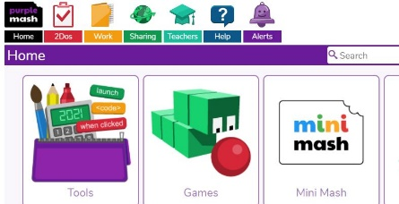 | Click on Work
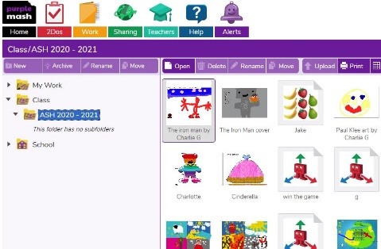 | Select which folder you want to upload your work into.  Your class folder is best because Mrs Burns and Mrs Mc are more likely to find it, but you can save it into your own My Work folder too.  Select Upload
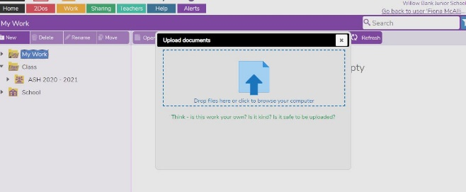 | Click on the blue arrow
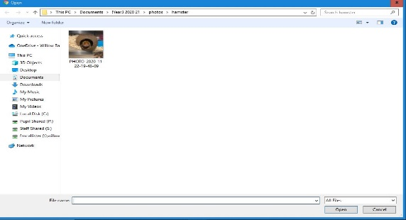 | Select the work from the folder it is saved in, on your device. Press open – your work will then appear in your PURPLE MASH folder.
Uploading work into the Shared BLOG on PURPLE MASH
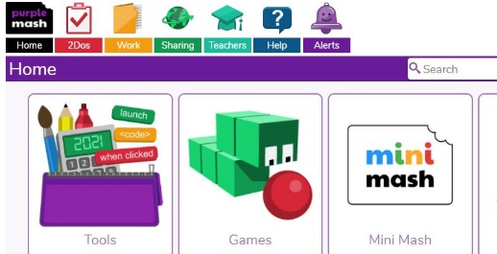 | Select Sharing
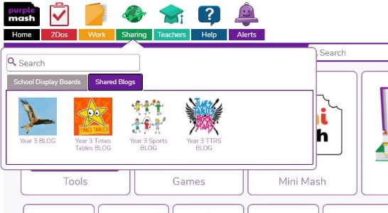 | Select Shared Blogs. Select which BLOG you want to post onto.
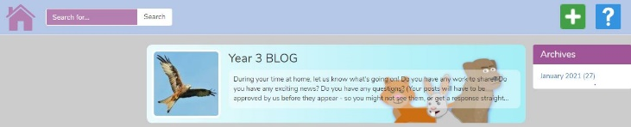 | Click on the green cross to add a post.
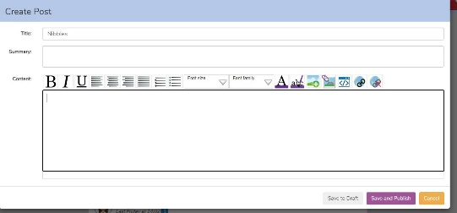 | Write a title, optional description, and then click in the box at the bottom.  Click on add image or work picker.
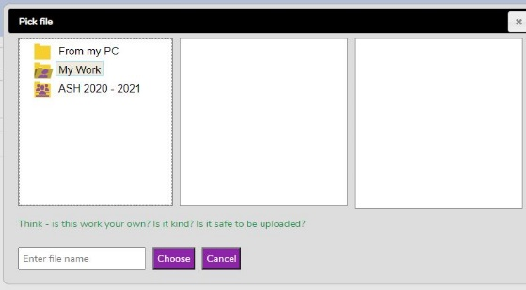 | Click on a folder to find your saved work.
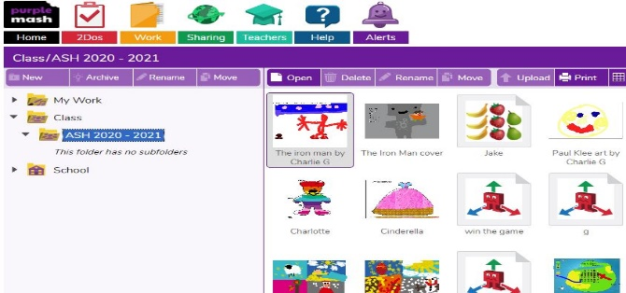 | Select the piece of work you want to share.
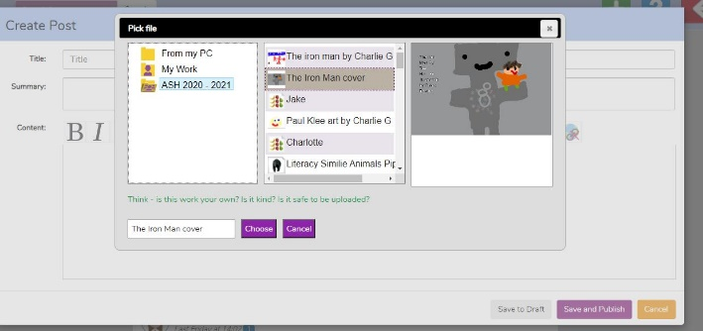 | Click choose
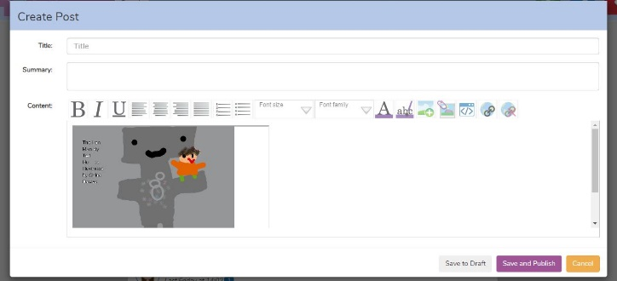 | Click save and publish  NB – your post won’t show until we have approved your post.

